**INDEX**

|  |  |
| --- | --- |
| **Sr.no.** | **Practical** |
| **1** | **Write a Program to demonstrate following operations.**  **A) Create Vector, Matrix and Tensor**  **B) Multiplication of two : Vector, Matrix and Tensor**  **C) Addition of two : Vector, Matrix and Tensor**  **D) Multiply Matrix with Vector**  **E) Matrix Dot product and Matrix Inverse** |
| **2** | **Performing matrix multiplication and finding Eigen vectors and Eigen values using TensorFlow** |
| **3** | **Solving XOR problem using deep feed forward network.** |
| **4** | **Implementing deep neural network for performing binary classification task.** |
| **5** | **Using a deep feed forward network with two hidden layers for performing linear regression and predicting values.** |
| **6** | **Evaluating feed forward deep network for multiclass Classification using K-Fold cross-validation** |
| **7** | **Implementation of convolutional neural network to predict numbers from number images** |
| **8** | **Demonstrate recurrent neural network that learns to perform sequence analysis for stock price.** |
| **9** | **Performing encoding and decoding of images usingdeep Autoencoder.** |
| **10** | **Denoising of images using Autoencoder.** |

**PRACTICAL: 1**

**Write a Program to demonstrate following operations.**

**A) Create Vector, Matrix and Tensor**

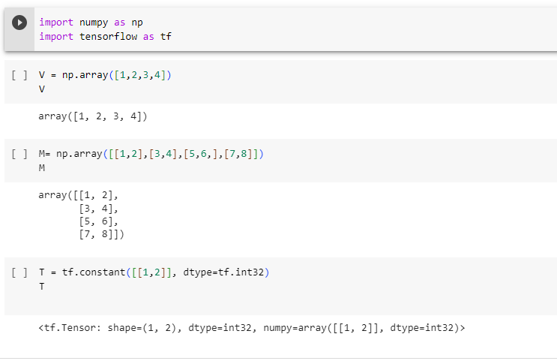

**1B) Multiplication of two : Vector, Matrix and Tensor**

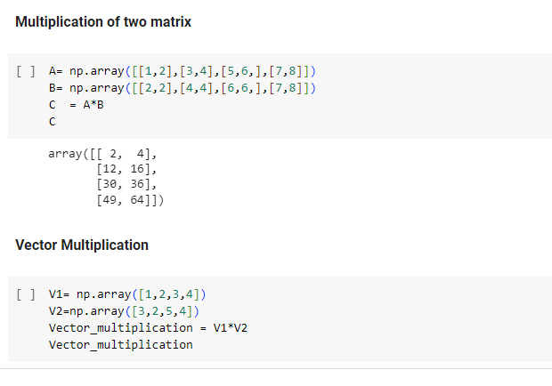

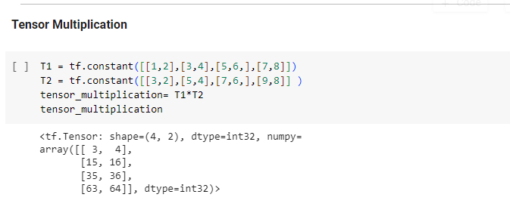

**1C)** **Addition of two : Vector, Matrix and Tensor**

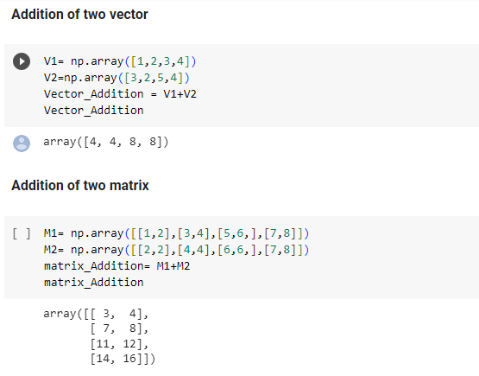

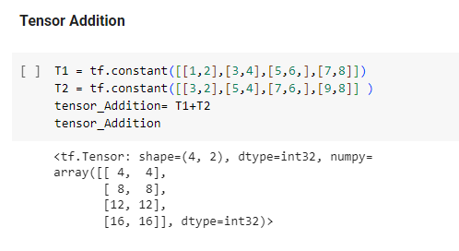

**1D) Multiply Matrix with Vector**

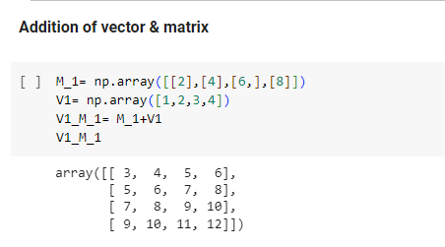

**1E)Matrix Dot product and Matrix Inverse**

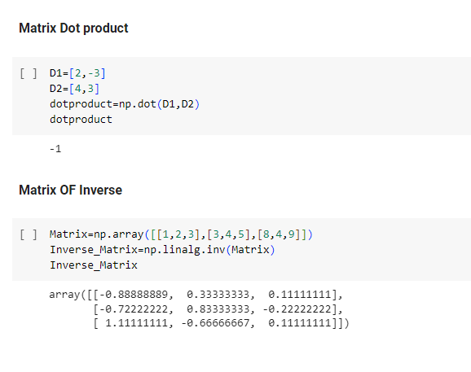

**PRACTICAL: 2**

**2A] Performing matrix multiplication and finding Eigen vectors and Eigen values using TensorFlow**

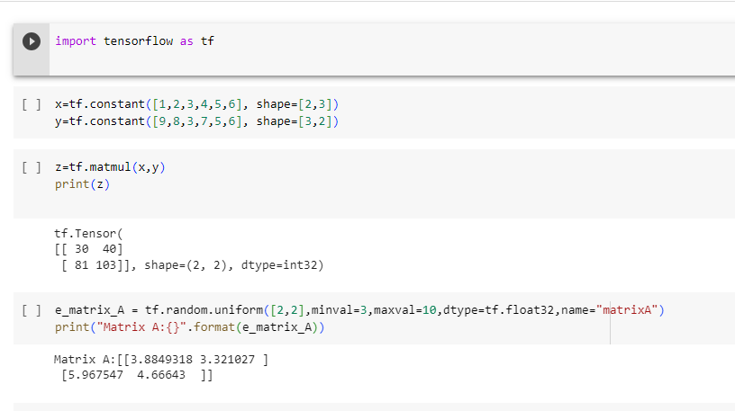

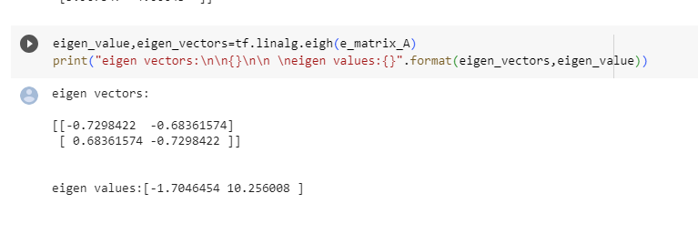

**PRACTICAL: 3**

**Aim : Solving XOR problem using deep feed forward network.**

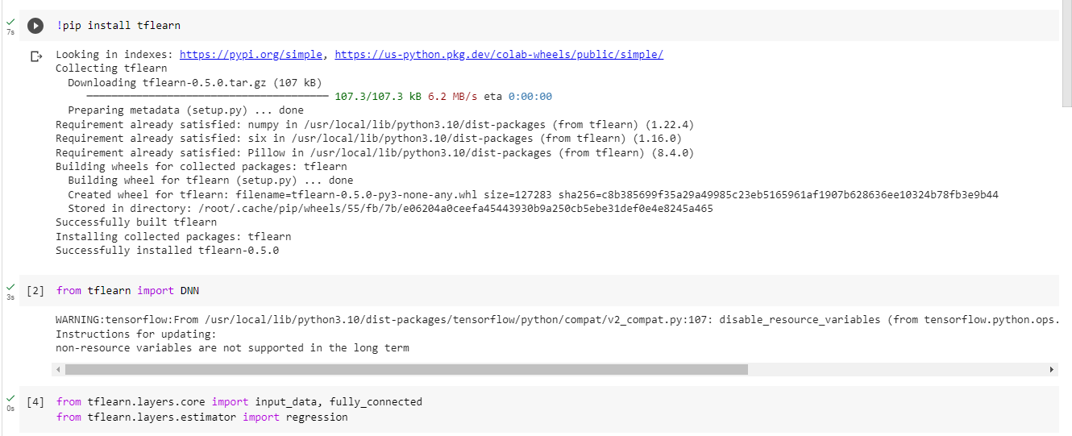

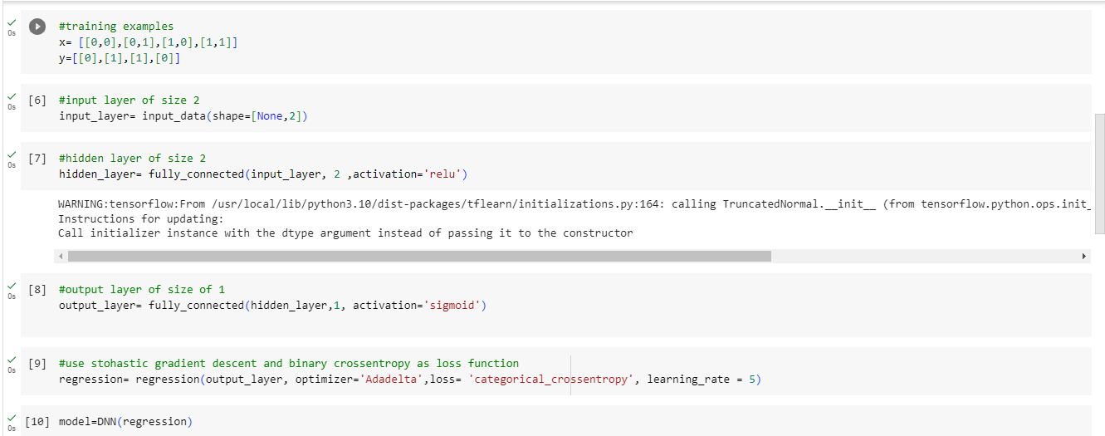

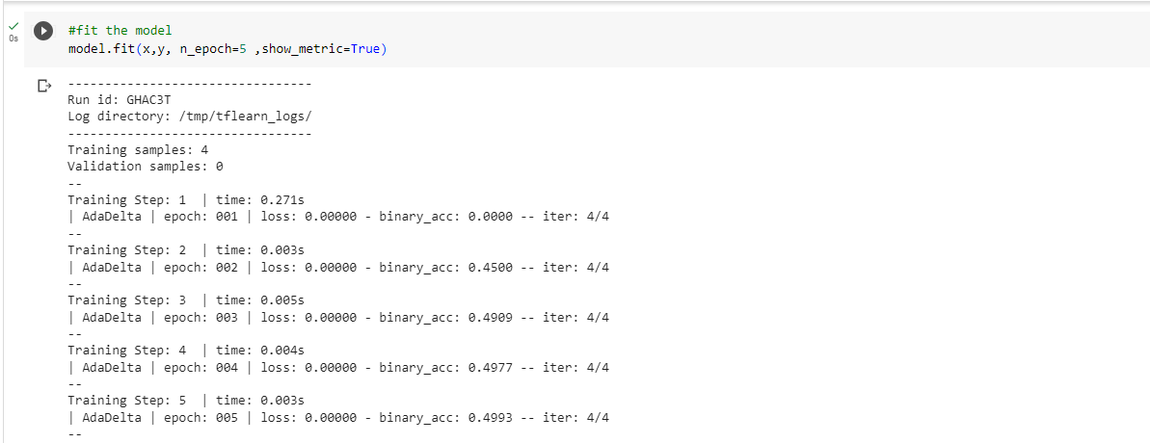

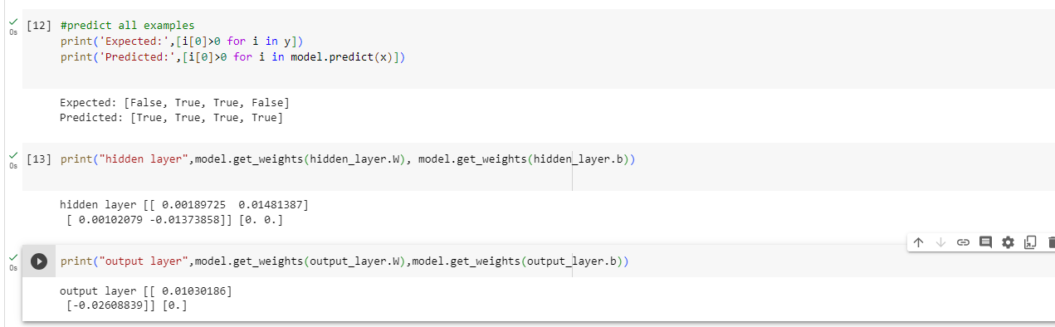

**PRACTICAL: 4**

**Aim: Implementing deep neural network for performing binary classification task.**

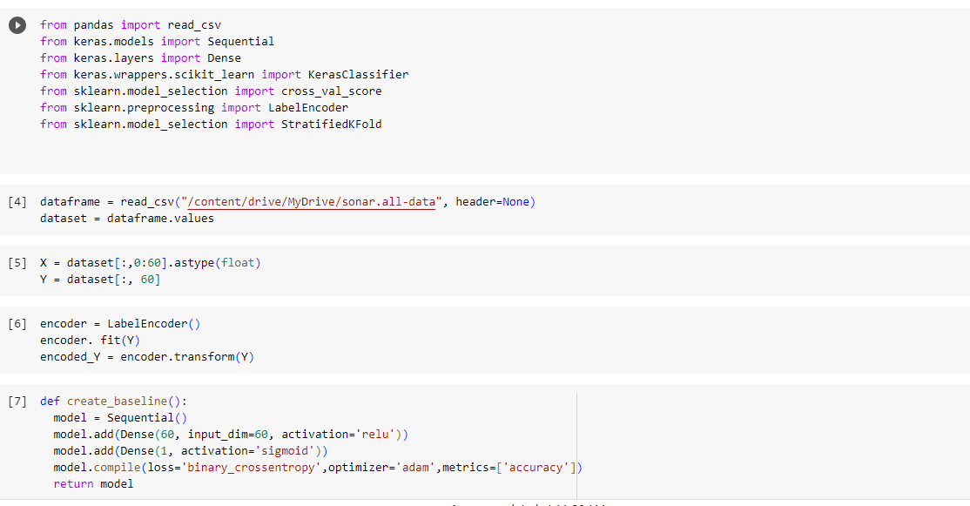

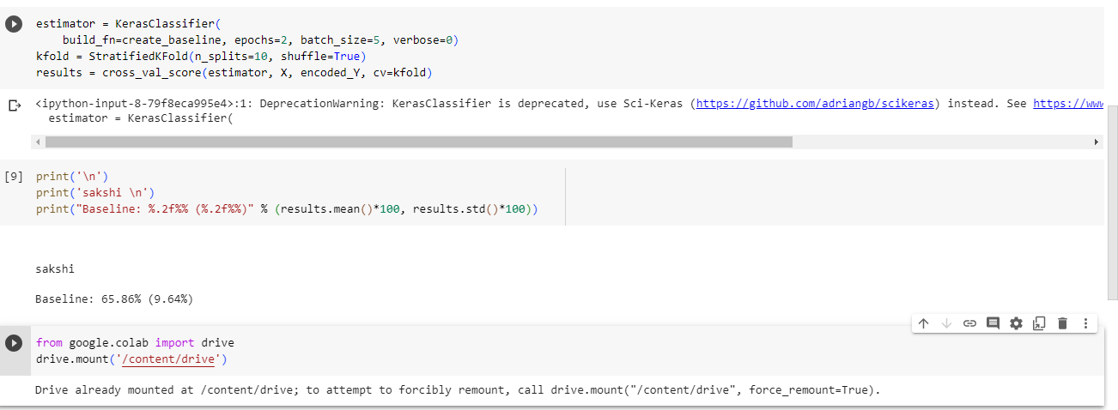

**PRACTICAL: 5**

**Aim: Using a deep feed forward network with two hidden layers for performing linear regression and predicting values.**

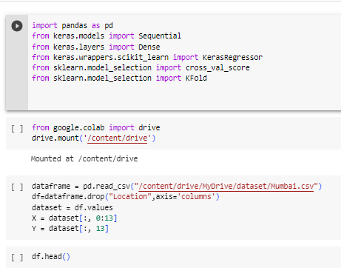

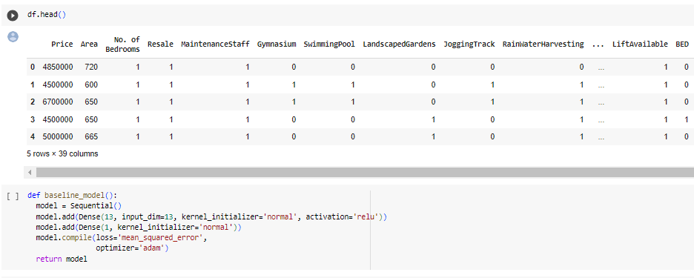

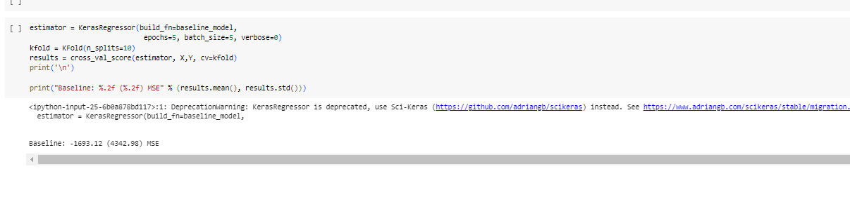

**PRACTICAL: 6**

**Aim : Evaluating feed forward deep network for multiclass Classification using K-Fold cross-validation.**

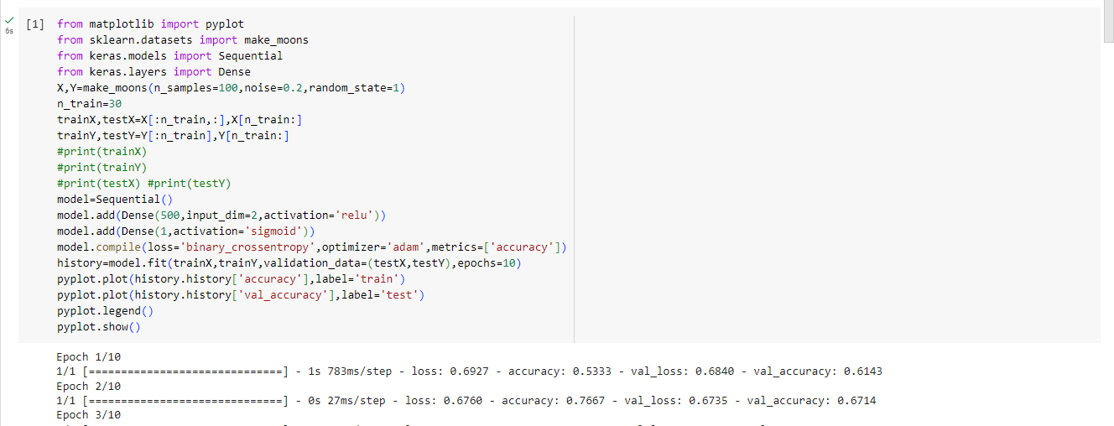

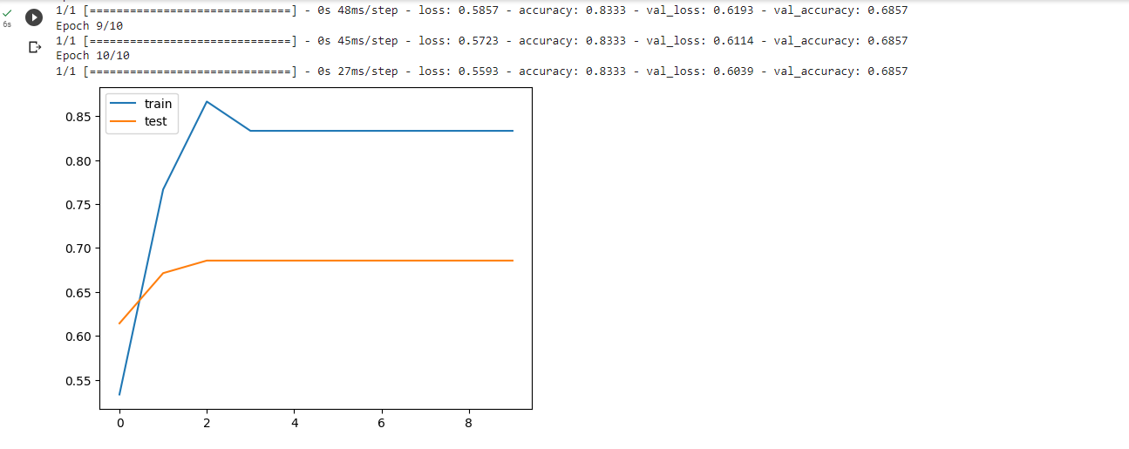

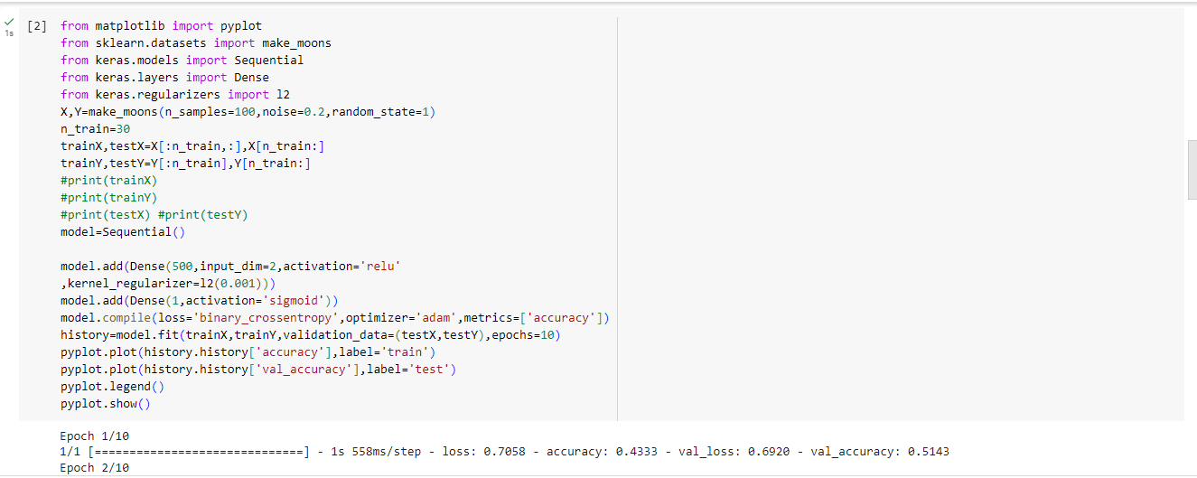

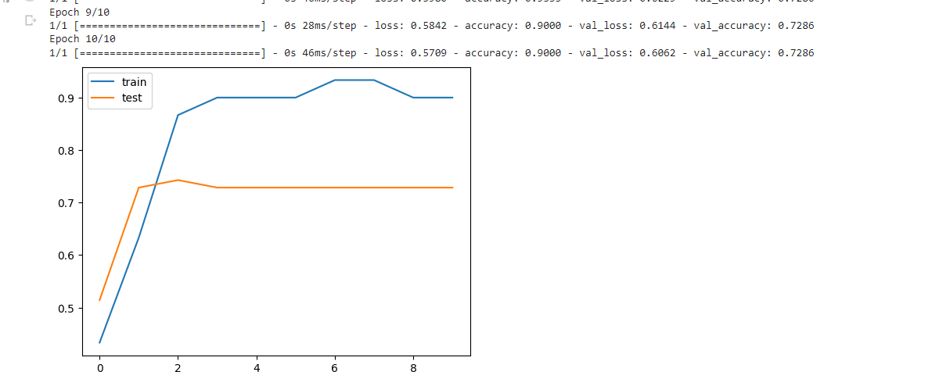

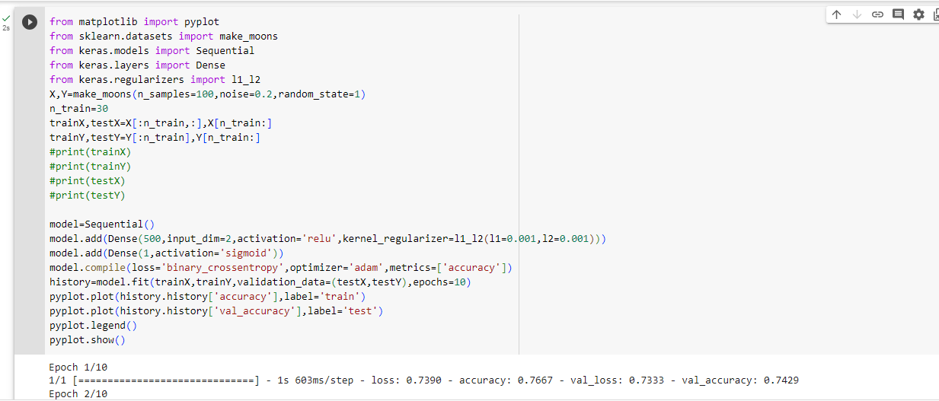

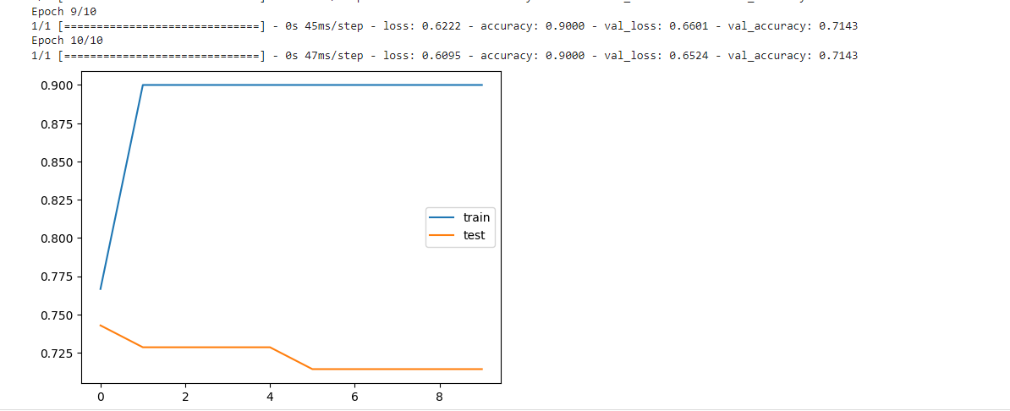

**PRACTICAL: 7**

**Aim: Implementation of convolutional neural network to predict numbers from number images**

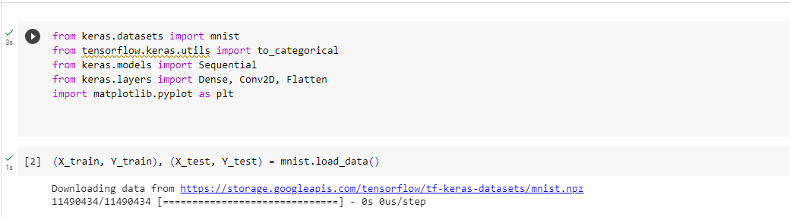

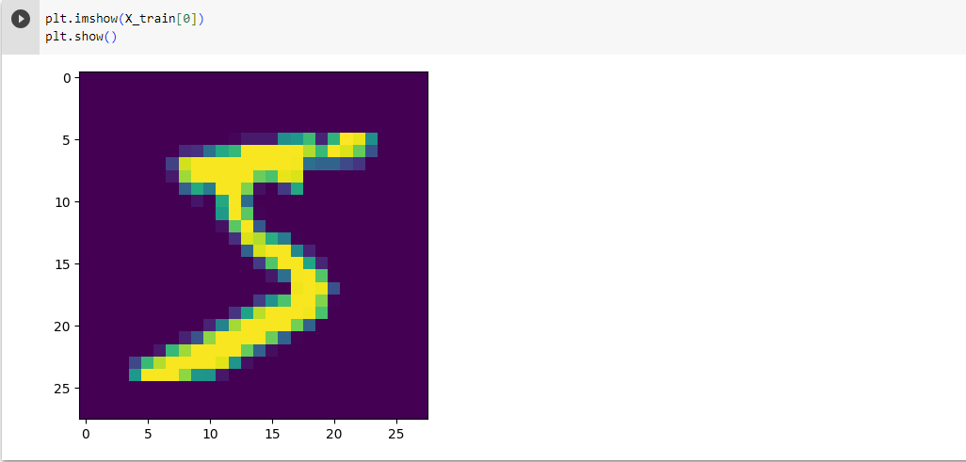

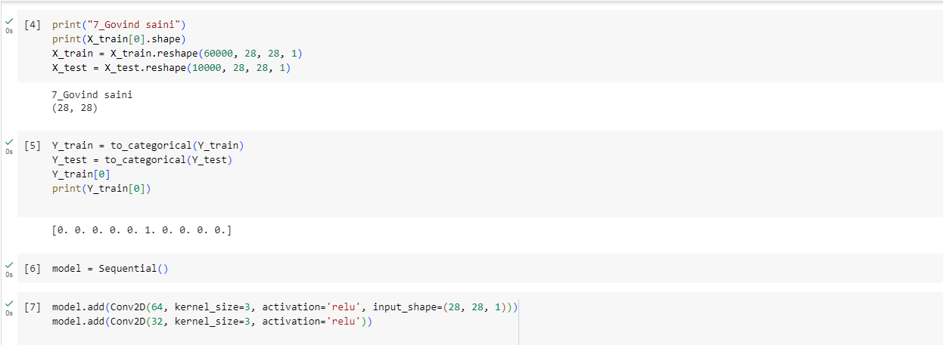

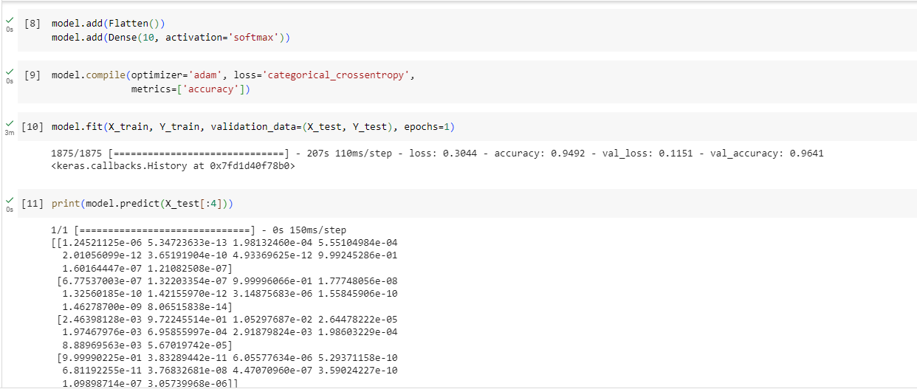

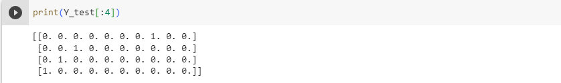

**PRACTICAL: 8**

**Aim: Demonstrate recurrent neural network that learns to perform sequence analysis for stock price**.

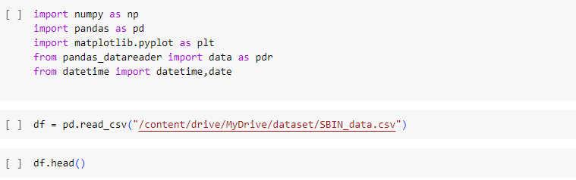

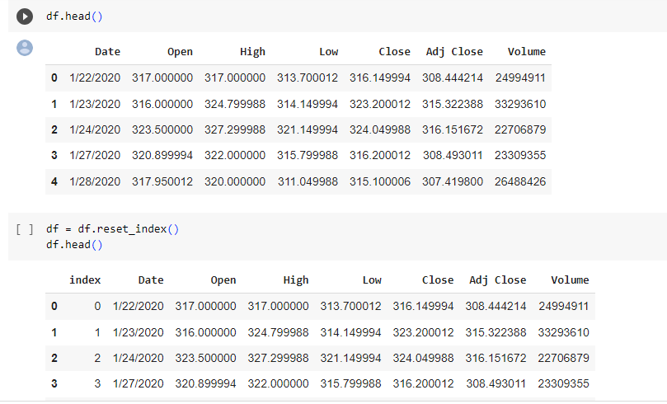

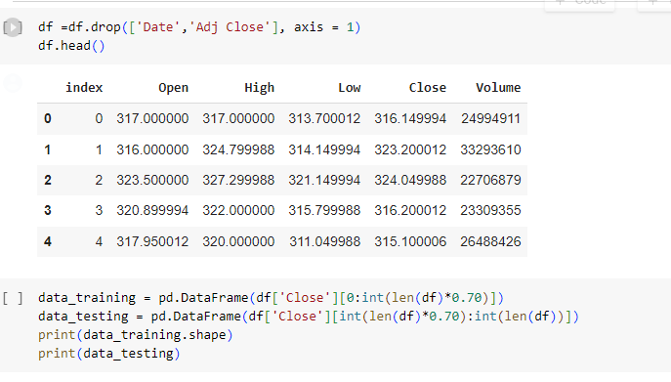

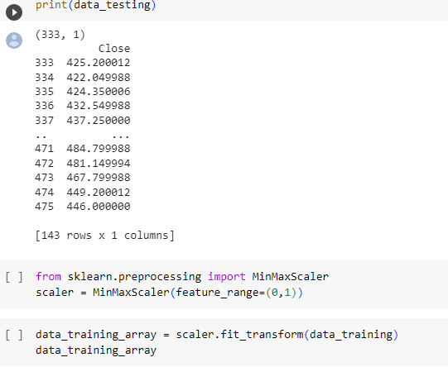

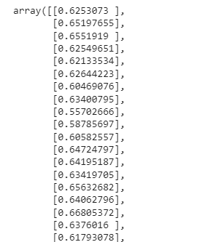

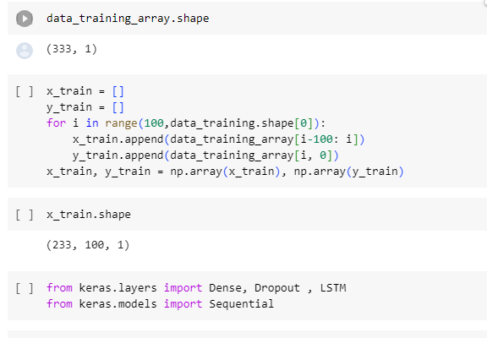

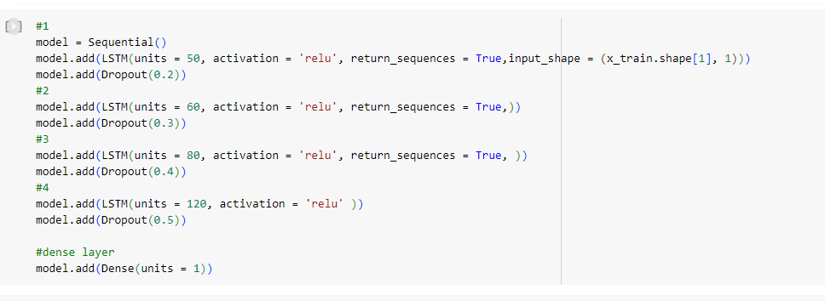

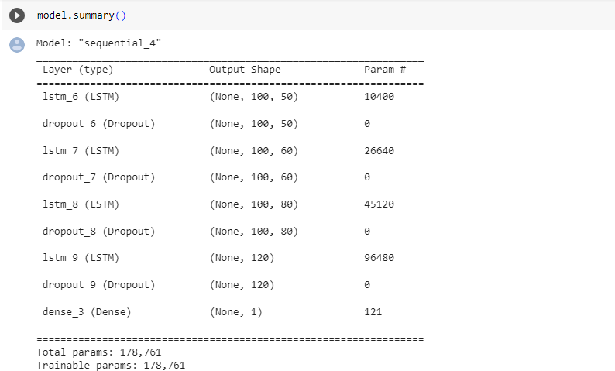

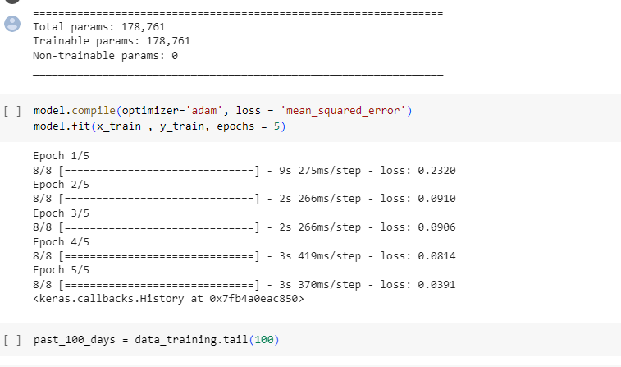

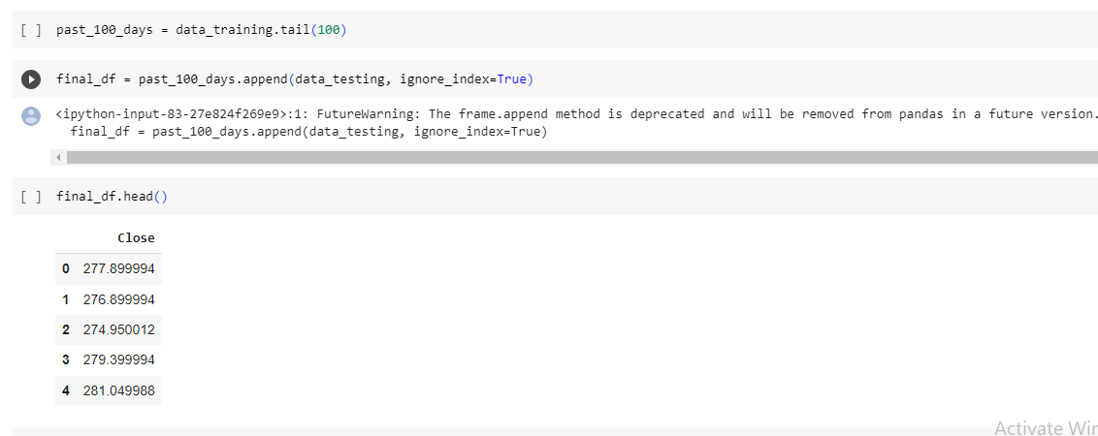

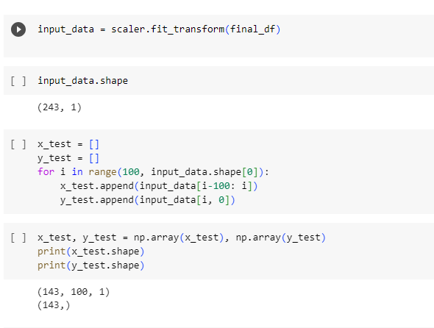

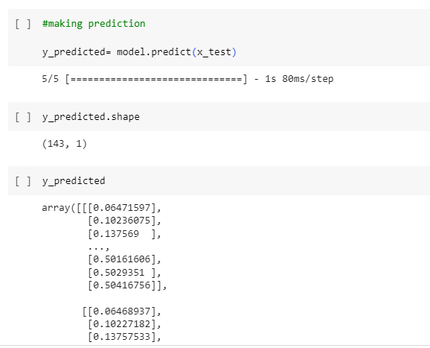

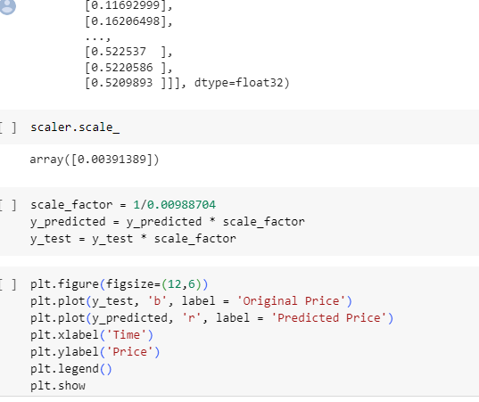

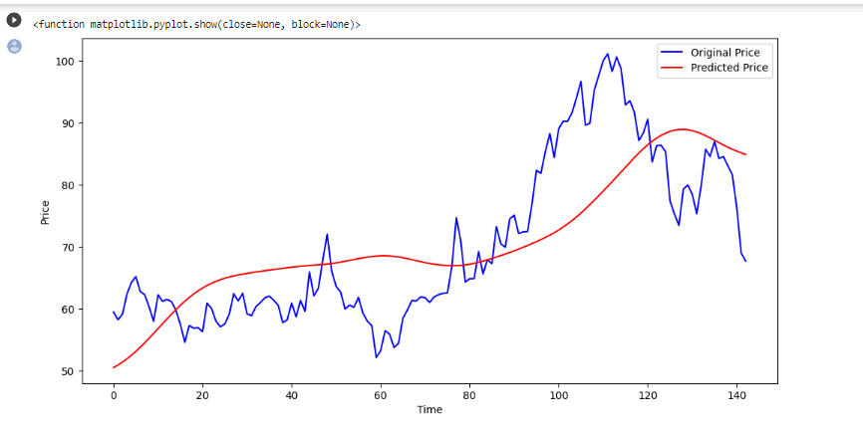

**PRACTICAL: 9**

**9A] Performing encoding and decoding of images using deep Autoencoder.**

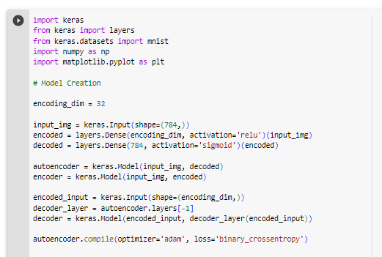

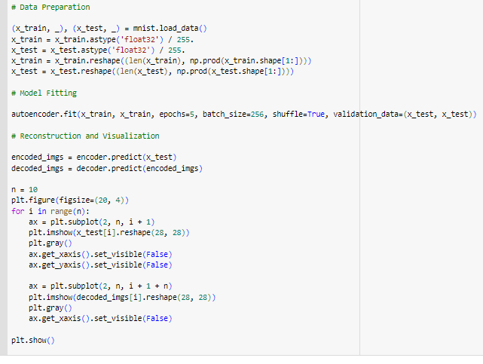

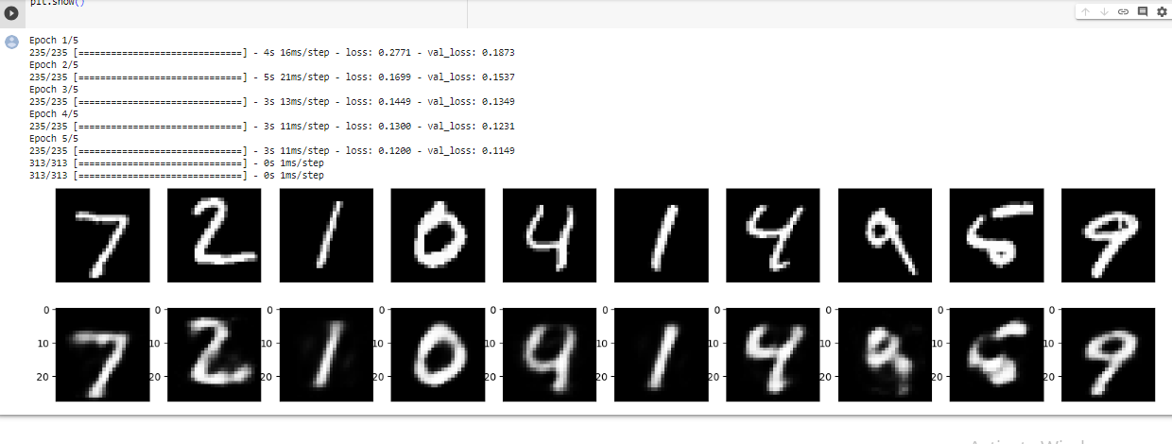

**PRACTICAL: 10**

**10A] Denoising of images using Autoencoder.**

